 | WorldSkills Mobile Robotics Junior Collection
- This kit contains over 1,449 individual pieces. Please ensure you are familiar with the contents.
- 3D Step files can be found You can also find them at https://studica.co/3d-cad-files
- Documentation & Training Material - https://docs.wsr.studica.com
- Training Videos – You can start with the following,
Day 1 - Getting started with WorldSkills Mobile Robotics
( https://www.youtube.com/watch?v=cFx3Id-mhvY )
- Competition Overview and Requirements
- Introduction to the World Skills Collection
- Hardware Construction Tips and Tricks
Day 2 – Building a basic robot
( https://www.youtube.com/watch?v=SBETsYISEag )
- Mechanical Build
      - Base Structure (Drive System)
      - Drive Type and Working Principles
      - 3 wheeled omni drive build
      - Sample Training Platform
- Electrical build
- Sample wiring of the Electrical System
Day 3 – Programming in Java
  - ( https://www.youtube.com/watch?v=aKBEbiiGRyg )
- Introduction to Programming
- Starting Java
- Example Projects for WorldsSkills-https://github.com/studica/WorldSkills-Example-Projects
- Configuring and Testing the SR Camera
Day 4 – Core Programming
  - ( https://www.youtube.com/watch?v=aSXyphb5jBo )
- Creating a Sample Project (Java)
- Basic Digital I/O
- Cobra Line Sensor Board
- Sharp I/R Sensor
- Ultrasonic Distance Sensor
- Basic Control of a DC Motor
- Basic Control of a Servo Motor
- Adding the Shuffleboard user Interface to see data
Day 5 - Design of a Basic Robot Control System
- ( https://www.youtube.com/watch?v=YLAldHITJ28 )
- Introduction to Programming the IMU (NavX)
- Gamepad Setup to Control and test robot functionality
- Introduction to Vision with the SR Camera
- Introduction to the Quick Driver Console
- Driving the Base Robot
- Review of Configuring the Titan QUAD
Worldskills Mobile Robotics Junior Parts List

Description | Part # | Image | # In Pack | Packs In Kit | Total  #
Electronics and Accessories
IR Range Sensor (10 cm to 80 cm) | 40117 | 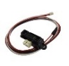 | 1 | 1 | 1
IR Range Sensor Bracket | 40118 | 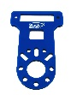 | 1 | 1 | 1
Zip Ties, Blue, 150mm (100 pack) | 70010 |  | 100 | 1 | 100
12V 3,000 mAh NiMH Battery Pack, PP45 | 70018 | 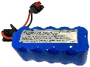 | 1 | 1 | 1
NiMH Battery Pack Charger, PP45 | 70019 | 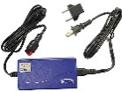 | 1 | 1 | 1
Powerpole 45 Extension Cable, 14AWG, 50cm | 70021 | 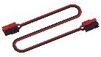 | 1 | 1 | 1
Robotics Toolbox | 70055 | 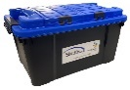 | 1 | 1 | 1
Remote Control Device | 70111 |  | 1 | 1 | 1
2.5mm Hex Ball End Screwdriver | 70142 | 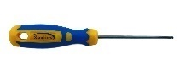 | 1 | 1 | 1
Hex Key Metric 7 Piece Set (1.5, 2, 2.5, 3, 4, 5, 6) | 70144-7 | 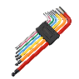 | 1 | 1 | 1
Combination Wrench, 5.5mm | 70145 | 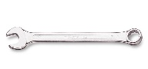 | 1 | 1 | 1
Cobra Line Follower Sensor | 70151 | 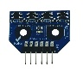 | 1 | 1 | 1
Titan Quad Motor Controller | 70152 | 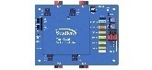 | 1 | 1 | 1
VMX Wire Pack | 70160 | 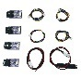 | 1 | 1 | 1
Titan Cable Pack w/1 CAN Cable & 2 JST-VH to JST-VH Cable | 70162 | 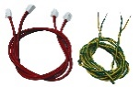 | 1 | 1 | 1
Power Control Panel | 70170 | 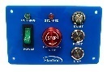 | 1 | 1 | 1
VMX Robotics Controller | 70176 | 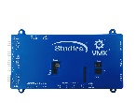 | 1 | 1 | 1
USB Cable, Type A to Type C, Blue, 2M | 70186 | 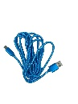 | 1 | 1 | 1
SR-Pro Ultrasonic Distance Sensor | 70753 | 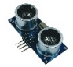 | 1 | 1 | 1
Ultrasonic Distance Sensor Bracket | 40238 | 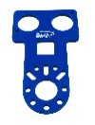 | 1 | 1 | 1
Analog Module w/JST-SH to JST-GH Cable | 70755 | 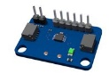 | 1 | 1 | 1
PWM cable Set - TJC8 3 pin, 22AWG, F-F - 12 pcs | 71011 | 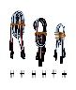 | 12 | 1 | 12
Dupont Single Pin, 4 wire, F-F Cable - 2 pack | 71014 | 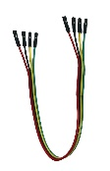 | 2 | 1 | 2
SR-Pro Camera | 71045 | 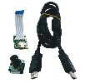 | 1 | 1 | 1
Short Lever Limit Switch (4 pack) | 72060 | 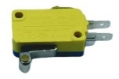 | 4 | 1 | 4
Maverick 12V DC Gear Motor w/Encoder | 75001 | 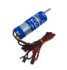 | 1 | 2 | 2
Multi-Mode Smart Servo | 75002 | 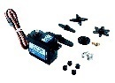 | 1 | 3 | 3
Smart Robot Servo Programmer | 75003 | 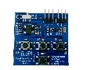 | 1 | 1 | 1
6V DC AA Battery Holder w/TJC8 Female, 22AWG | 75004 | 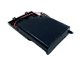 | 1 | 1 | 1
Servo Power Block | 75006 | 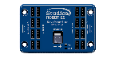 | 1 | 1 | 1
U-Channel
336mm U-Channel | 76012 | 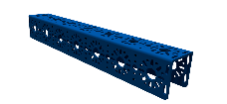 | 1 | 2 | 2
288mm U-Channel (2 pack) | 76013-2 | 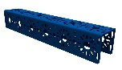 | 2 | 1 | 2
192mm U-Channel | 76015 | 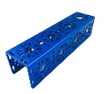 | 1 | 2 | 2
144mm U-Channel (2 pack) | 76016-2 | 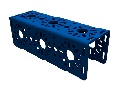 | 2 | 1 | 2
96mm U-Channel (2 pack) | 76017-2 | 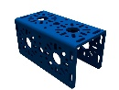 | 2 | 1 | 2
48mm U-Channel (2 pack) | 76018-2 | 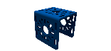 | 2 | 2 | 4
288mm Low U-Channel (2 pack) | 76028-2 | 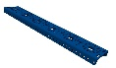 | 2 | 1 | 2
Flat Beams
288mm Flat Beam (2 pack) | 76043-2 | 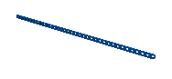 | 2 | 2 | 4
96mm Flat Beam (2 pack) | 76047-2 | 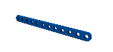 | 2 | 2 | 4
Flat Brackets
288mm x 40mm Flat Bracket (2 pack) | 76061-2 | 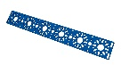 | 2 | 1 | 2
192mm x 40mm Flat Bracket (2 pack) | 76063-2 | 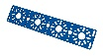 | 2 | 1 | 2
144mm x 40mm Flat Bracket (2 pack) | 76064-2 |  | 2 | 1 | 2
96mm x 40mm Flat Bracket (2 pack) | 76065-2 |  | 2 | 1 | 2
192mm x 96mm Flat Bracket (2 pack) | 76066-2 | 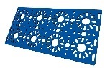 | 2 | 1 | 2
Irregular Brackets
96mm Adjustable Flat Bracket (2 pack) | 76083-2 |  | 2 | 1 | 2
Inside U Bracket (2 pack) | 76086-2 | 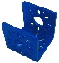 | 2 | 2 | 4
L Bracket (2 pack) | 76087-2 | 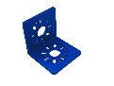 | 2 | 3 | 6
Battery Clip (2 pack) | 76088-2 | 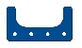 | 2 | 1 | 2
Inside L Bracket (2 pack) | 76089-2 | 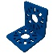 | 2 | 2 | 4
Mounting Plates
Motor Mount Plate | 76140 | 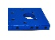 | 1 | 2 | 2
Motor Mount Clamp Kit | 76141 |  | 1 | 2 | 2
End Piece Plate (2 pack) | 76143-2 | 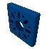 | 2 | 3 | 6
Servo Standard Front Mount | 76144 | 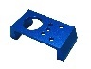 | 1 | 3 | 3
Servo Mount Flat Plate | 76145 | 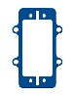 | 1 | 3 | 3
Servo Mount Offset Plate | 76146 |  | 1 | 3 | 3
Servo Horn 25T | 76148 | 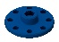 | 1 | 3 | 3
6mm D-Shaft Servo Hub 25T | 76149 | 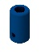 | 1 | 3 | 3
Axles, Slides, Rack & Pinion
6mm x 35mm D-Shaft (6 pack) | 76159-6 | 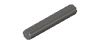 | 6 | 1 | 6
6mm x 70mm D-Shaft (6 pack) | 76160-6 | 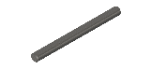 | 6 | 1 | 6
6mm x 96mm D-Shaft (6 pack) | 76161-6 | 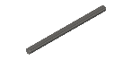 | 6 | 1 | 6
6mm x 432mm D-Shaft (2 pack) | 76162-2 | 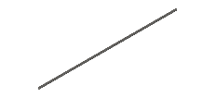 | 2 | 1 | 2
Rack & Pinion Set | 76170 | 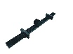 | 1 | 2 | 2
Standoffs
42mm Standoff (12 pack) | 76180-12 |  | 12 | 1 | 12
48mm Standoff (12 pack) | 76181-12 |  | 12 | 1 | 12
25mm Standoff (12 pack) | 76182-12 |  | 12 | 1 | 12
Screws, Nuts
M3 x 8mm Socket Head Cap Screw (pack of 100) | 76200-100 | 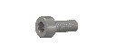 | 100 | 2 | 200
M3 x 10mm Socket Head Cap Screw (pack of 100) | 76201-100 | 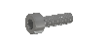 | 100 | 2 | 200
M3 x 12mm Socket Head Cap Screw (pack of 100) | 76202-100 | 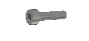 | 100 | 2 | 200
M3 x 10mm Button Head Cap Screw (pack of 50) | 76203-50 | 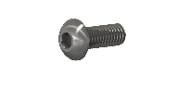 | 50 | 1 | 50
M3 x 20mm Socket Head Cap Screw (pack of 50) | 76209-50 |  | 50 | 1 | 50
M3 x 30mm Socket Head Cap Screw (pack of 50) | 76206-50 |  | 50 | 1 | 50
M3 Kep Nut (pack of 100) | 76204-100 | 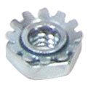 | 100 | 2 | 200
M3 Nyloc Nut (pack of 100) | 76205-100 | 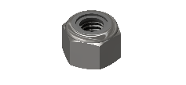 | 100 | 1 | 100
Gears, Sprockets, Pulleys, Belts
32 Tooth Gear (2 pack) | 76220-2 |  | 2 | 2 | 4
64 Tooth Gear (2 pack) | 76221-2 |  | 2 | 2 | 4
6mm Timing Pulley, 10 Tooth (2 pack) | 76232-2 | 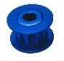 | 2 | 1 | 2
10mm Timing Belt (1 meter) | 76233 | 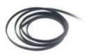 | 1 | 1 | 1
Bushings, Bearings, Coupling, Collars and Spacers
6mm Shaft Hub (4 pack) | 76284-4 | 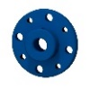 | 4 | 2 | 8
Bushing Bronze 6mm ID x 8mm OD (12 pack) | 76300-12 | 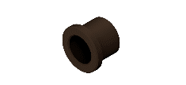 | 12 | 1 | 12
Bushing Bronze 6mm ID x 14mm OD (12 pack) | 76301-12 | 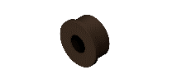 | 12 | 1 | 12
Flange Bearing 6mm ID, 14mm OD, 15mm Flange (12 pack) | 76302 | 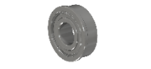 | 12 | 1 | 12
Coupling 6mm ID D-Shaft, 12mm OD (2 pack) | 76303-2 | 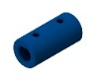 | 2 | 2 | 4
Collar 6mm ID D-Shaft, 12mm OD (6 pack) | 76304-6 | 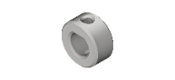 | 6 | 2 | 12
Shaft Spacer Plastic 6mm ID x 10mm OD x 1mm L (24 pack) | 76305-24 |  | 24 | 1 | 24
Shaft Spacer Plastic 6mm ID x 10mm OD x 2mm L (24 pack) | 76306-24 |  | 24 | 1 | 24
Shaft Spacer Plastic 6mm ID x 10mm OD x 5mm L (12 pack) | 76307-12 |  | 12 | 1 | 12
Shaft Spacer Plastic 6mm ID x 10mm OD x 20mm L (6 pack) | 76308-6 | 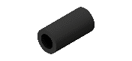 | 6 | 1 | 6
Wheels
Omni Wheel (100mm, Double Plastic, w/ integrated 6mm Hub) | 76260 | 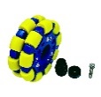 | 1 | 2 | 2
100mm Drive Wheel – 25mm Thick, 50A Durometer | 76262 | 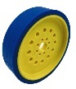 | 1 | 2 | 2

